Name Period

Homework

For use after Lesson 4.5

4.5

Write the linear equation in slope-intercept form.

1.  2.  **3.** 

Graph the linear equation using intercepts (x=0; then, y=0). Keep in Standard Form.

4.  5. 

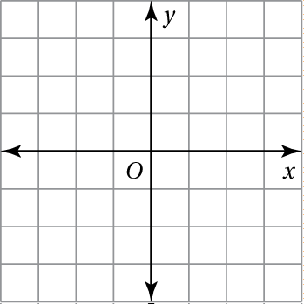 

6. You go shopping and buy *x* shirts for $12 and *y* jeans for $28. The total   
spent is $84.

a. Write an equation in standard form that models how much money   
you spent.



b. Graph the equation and interpret the intercepts.